A4009-Afr-Egy-Karnak Temple, Luxor-Ramses and ankh-1213 BCE

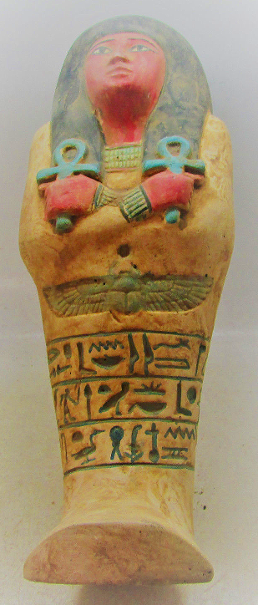

Afr-Egy-Karnak Temple, Luxor-Ramses and ankh-1213 BCE

Case no.: 2

Accession Number:

Formal Label: Afr-Egy-Karnak Temple, Luxor-Ramses and ankh-1213 BCE

**Display Description:**

**Ramses** ([Ancient Egyptian](https://en.wikipedia.org/wiki/Ancient_Egyptian_language): *rꜥ-ms-sw* "[Ra](https://en.wikipedia.org/wiki/Ra) is the one who bore him" > [Koine Greek](https://en.wikipedia.org/wiki/Koine_Greek): Ῥαμέσσης, [translit.](https://en.wikipedia.org/wiki/Romanization_of_Greek) *Rhaméssēs*);[[6]](https://en.wikipedia.org/wiki/Ramesses_II" \l "cite_note-6) born c. 1303 BC; died July or August 1213; reigned 1279–1213[[7]](https://en.wikipedia.org/wiki/Ramesses_II" \l "cite_note-7)), also known as **Ramesses the Great**, was the third [pharaoh](https://en.wikipedia.org/wiki/Pharaoh) of the [Nineteenth Dynasty of Egypt](https://en.wikipedia.org/wiki/Nineteenth_Dynasty_of_Egypt). He is often regarded as the greatest, most celebrated, and most powerful pharaoh of the [New Kingdom](https://en.wikipedia.org/wiki/New_Kingdom_of_Egypt).[[8]](https://en.wikipedia.org/wiki/Ramesses_II" \l "cite_note-putnam-8) His successors and later Egyptians called him the "Great Ancestor".

He is known as [**Ozymandias**](https://en.wikipedia.org/wiki/Ozymandias_(disambiguation)) in Greek sources ([Koine Greek](https://en.wikipedia.org/wiki/Koine_Greek): Οσυμανδύας *Osymandýas*),[[9]](https://en.wikipedia.org/wiki/Ramesses_II" \l "cite_note-9)from the first part of Ramesses' [regnal name](https://en.wikipedia.org/wiki/Regnal_name), *Usermaatre*[*Setepenre*](https://en.wikipedia.org/wiki/Setepenre), "The [Maat](https://en.wikipedia.org/wiki/Maat) of [Ra](https://en.wikipedia.org/wiki/Ra) is powerful, Chosen of Ra".[[10]](https://en.wikipedia.org/wiki/Ramesses_II" \l "cite_note-pdsOzymandias-10)

Ramesses II led several military expeditions into the [Levant](https://en.wikipedia.org/wiki/Levant), reasserting Egyptian control over [Canaan](https://en.wikipedia.org/wiki/Canaan). He also led expeditions to the south, into [Nubia](https://en.wikipedia.org/wiki/Nubia), commemorated in inscriptions at [Beit el-Wali](https://en.wikipedia.org/wiki/New_Kalabsha" \l "Beit_al-Wali) and [Gerf Hussein](https://en.wikipedia.org/wiki/New_Kalabsha" \l "Gerf_Hussein). The early part of his reign was focused on building cities, temples, and monuments. He established the city of [Pi-Ramesses](https://en.wikipedia.org/wiki/Pi-Ramesses) in the [Nile Delta](https://en.wikipedia.org/wiki/Nile_Delta) as his new capital and used it as the main base for his campaigns in [Syria](https://en.wikipedia.org/wiki/Syria_(region)). At fourteen, he was appointed [prince regent](https://en.wikipedia.org/wiki/Prince_regent) by his father, [Seti I](https://en.wikipedia.org/wiki/Seti_I).[[8]](https://en.wikipedia.org/wiki/Ramesses_II" \l "cite_note-putnam-8) He is believed to have taken the throne in his late teens and is known to have ruled Egypt from 1279 to 1213 BC.[[11]](https://en.wikipedia.org/wiki/Ramesses_II" \l "cite_note-11)[Manetho](https://en.wikipedia.org/wiki/Manetho) attributes Ramesses II a reign of 66 years and 2 months; most Egyptologists today believe he assumed the throne on May 31, 1279 BC, based on his known accession date of III [Season of the Harvest](https://en.wikipedia.org/wiki/Season_of_the_Harvest), day 27.[[12]](https://en.wikipedia.org/wiki/Ramesses_II" \l "cite_note-12)[[13]](https://en.wikipedia.org/wiki/Ramesses_II" \l "cite_note-13) Estimates of his age at death vary; 90 or 91 is considered most likely.[[14]](https://en.wikipedia.org/wiki/Ramesses_II" \l "cite_note-14)[[15]](https://en.wikipedia.org/wiki/Ramesses_II" \l "cite_note-15) Ramesses II celebrated an unprecedented fourteen [Sed festivals](https://en.wikipedia.org/wiki/Sed_festival) (the first held after 30 years of a pharaoh's reign, and then, every three years) during his reign—more than any other pharaoh.[[16]](https://en.wikipedia.org/wiki/Ramesses_II" \l "cite_note-16) On his death, he was buried in [a tomb](https://en.wikipedia.org/wiki/KV7) in the [Valley of the Kings](https://en.wikipedia.org/wiki/Valley_of_the_Kings);[[17]](https://en.wikipedia.org/wiki/Ramesses_II" \l "cite_note-17) his body was later moved to a [royal cache](https://en.wikipedia.org/wiki/DB320) where it was discovered in 1881, and is now on display in the [Egyptian Museum](https://en.wikipedia.org/wiki/Egyptian_Museum).[[18]](https://en.wikipedia.org/wiki/Ramesses_II" \l "cite_note-18)

**After wikipedia**

**LC Classification:**

Date or Time Horizon: 664-332 BCE

Geographical Area:

**Map:**

**GPS coordinates:**

Cultural Affiliation:

Media:

Dimensions:

Weight:

Condition:

Provenance:

**Discussion:**

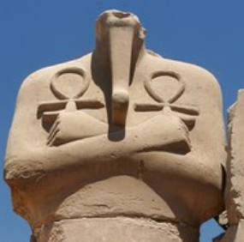

**Headless statue of Ramses II Karnak Temple, Luxor, I similar tothis Mummy statue and may be that of Ramses II.**

**References:**